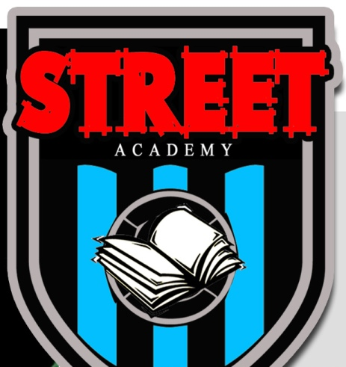


Youth Development and Education Department

NULITES:
(National Urban League Incentive to Excel and Succeed)

The Street Academy

Participant Behavioral Agreement

I, _________________, as a participant in the NULITES Street Academy Program, agree to commit to the NULITES Pledge:
- Strive for excellence at home, school and in my community
- Work within my neighborhood to further its development
- Respect my mind and body as well as the mind and bodies of others
- Celebrate my heritage and culture, as well as those of others
- Create a better future for myself, my family, and other people
- Care for the world’s people and environment
- Promote a universal spirit of cooperation and peace

In addition, to the seven NULITES principles stated above, I agree to:

- Dress appropriately and be neat, clean and presentable.
- Take responsibility for my own behavior and show respect for staff, volunteers, the bus driver, other youth participants, the facilities and myself.
- Follow the instructions of my teachers, staff and the bus driver at all times.
- Participate in all lessons, activities, discussions and interviews.
- Do my absolute best in the program at all times.
- Be waiting on time for the bus to pick me up.
- Stay seated at all times while the bus is moving.
- Keep my hands to my self.
- Be drug and alcohol free.
- Not bring any type of object that could be considered or used as a weapon.
- Clean up after myself
- Report any problems to my teacher.
- Not bring any food or drinks on the bus.
- Not change pick up or drop off addresses unless family moves.
- Inform teachers or Program Specialist if transportation is no longer needed.
- Not bring electronic devices on bus/ to program, i.e., no ipods, cd or dvd players.
- Not talk/use cell phones unless an emergency occurs.

_____________________________ ______________
(Participant’s Signature) (Date)

______________________________ ______________
(Parent’s Signature) (Date)

